M-3
- Create use-cases for a hotel booking application.

ANS:- Use-Cases for a Hotel Booking Application:
- User Registration and Login:
Users can create an account, log in securely, and manage their personal details.
- Search and Book Hotel Rooms:
Users can search for hotels based on location, date, price, and amenities, then book rooms online.
- Payment and Booking Confirmation:
Users can make online payments through various modes (credit/debit card, UPI, wallet) and receive booking confirmation details.

- Create a clear method to separate user requirement from system requirements in a healthcare management system.

ANS:- Method to separate user requirements from system requirements (Healthcare Management System)
- Step 1: Identify stakeholders – doctors, nurses, patients, and administrators.
- Step 2: Gather user requirements – what each user wants (e.g., appointment booking, viewing medical history).
- Step 3: Derive system requirements – how the system will support those needs (e.g., database, login module, security).
- Step 4: Document separately – user requirements in natural language, system requirements in technical form.

- Formulate a systematic approach for using data dictionary entries to validate the consistency of requirements specification.

ANS:- Using data dictionary to validate consistency of requirements
- A data dictionary defines all data elements — name, type, range, format, and description.
- It ensures that all terms in the SRS are used consistently and unambiguously.
- During validation, compare each data term in the requirement specification with its data dictionary entry.
- Conflicts or mismatched definitions are corrected to maintain data integrity and clarity.

- Propose a structured format for documenting functional requirements that enables traceability and impact analysis of changes.

ANS:- A proper documentation format improves traceability and change management:
Field | Description
ID | Unique identifier (e.g., FR-01)
Title | Short name of the function
Description | Details of what the function does
Inputs/Outputs | Expected data and results
Dependencies | Related modules or conditions
Traceability | Link to design, code, and test cases

- Create a multi-user requirement gathering approach using viewpoint oriented analysis.
ANS:- Multi-user requirement gathering using viewpoint-oriented analysis
- Identify viewpoints – admin, patient, doctor, pharmacist, etc.
- Collect requirements from each viewpoint using interviews, workshops, and observation.
- Record each viewpoint’s goals and responsibilities.
- Integrate all views to form a single requirement model, resolving overlaps or conflicts.
- Design a change management process that protects SRS integrity while adapting to evolving needs.

ANS:- Change management process to protect SRS integrity
- Submit Change Request (CR): User or developer proposes modification.
- Impact Analysis: Evaluate effect on functionality, cost, and schedule.
- Approval Process: Review by change control board (CCB).
- Implementation & Update: Apply approved changes, update version of SRS.
- Communication: Notify all stakeholders.

- Build a process for validating requirements to avoid conflicts and ensure compliness in a financial application.

ANS:- Process for validating requirements in financial application
- Requirement Review: Conduct walkthroughs with clients and domain experts.
- Traceability Matrix: Map each requirement to design and test cases.
- Consistency Check: Ensure no conflicting or duplicate requirements.
- Compliance Check: Verify alignment with financial regulations and data security norms.
- Develop a step-by-step method to evaluate the feasibility of a software project focusing on operational and schedule aspects.
ANS:- Feasibility evaluation focusing on operational & schedule aspects
- Operational Feasibility: Check if system meets user needs and fits into current workflow.
- Technical Feasibility: Ensure necessary technology and skills exist.
- Economic Feasibility: Compare expected benefits vs. cost.
- Schedule Feasibility: Analyze project timeline, resource availability, and milestones.
9.Create a complete quality management system covering quality control, assurance and improvement for software project.
ANS:- Quality Management System (QMS)
A complete QMS includes:
- Quality Control (QC): Testing and reviewing code to detect defects.
- Quality Assurance (QA): Following defined processes and standards like ISO or CMMI.
- Quality Improvement (QI): Using metrics and feedback to enhance future performance.
- Continuous monitoring ensures software reliability, performance, and user satisfaction.
10.Design a software maintenance plan that includes corrective, adaptive, perfective, and preventive maintenance with proper process models.
ANS:- Software Maintenance Plan
Types of maintenance with process models:
- Corrective: Fixing software defects after delivery.
- Adaptive: Modifying system for new environments (OS, hardware).
- Perfective: Improving performance or adding enhancements.
- Preventive: Anticipating and preventing future problems.
Use models like Iterative or Spiral for continuous updates and version control.
11.Plan a method for updating legacy systems using reuse and modern testing practices.
ANS:- Updating legacy systems using reuse and modern testing
- System Analysis: Identify components that can be reused or need replacement.
- Code Reuse: Preserve well-tested legacy modules.
- Modernization: Migrate to newer platforms using APIs or cloud solutions.
- Testing: Apply automated and regression testing to ensure stability.
12.Design a strategy to gather both functional and non functional requirements from various stakeholders for a new e-commerce platform.
ANS:- Strategy to gather functional & non-functional requirements (E-commerce platform)
- Identify stakeholders: customers, admins, sellers, delivery partners.
- Functional requirements: Collected via interviews, user stories, and use-cases (e.g., cart, payment, search).
- Non-functional requirements: Gather through surveys and performance metrics (e.g., speed, security, reliability).
- Consolidate and prioritize: Combine and validate with stakeholders for completeness.
M-4(3- Marks)
- Demonstrate unit testing on a login module.
ANS:- . Demonstrate unit testing on a login module
- Unit testing checks individual functions or components of the program.
- Example for a login module:
  - Test cases:
    - Valid username and password → Login successful
    - Invalid username → Error message
    - Blank password → Prompt for input
    - SQL injection attempt → Should be blocked
- Use tools like JUnit or PyTest to verify that the login function works as expected.
- Apply Blackbox testing for a E-commerce cart?
ANS:- Apply Black-box testing for an E-commerce cart
- Black-box testing focuses on functionality, not internal code.
- Example for shopping cart:
  - Add items → Verify total price updates correctly.
  - Remove items → Total decreases properly.
  - Apply discount code → Correct discount applied.
  - Checkout → Correct order summary displayed.
- Use equivalence partitioning to test getDate inputs.
ANS:- Use equivalence partitioning to test getDate inputs
- Equivalence Partitioning (EP) divides input data into valid and invalid classes.
- Example for getDate(day, month, year):
  - Valid partitions:
    - Day: 1–31, Month: 1–12, Year: 1900–2100
  - Invalid partitions:
    - Day: <1 or >31, Month: <1 or >12, Year: <1900 or >2100
- Choose one test case from each partition (e.g., day=15, month=5, year=2025).
- Illustrate how validation testing is perfrom?
ANS:- Illustrate how validation testing is performed
- Validation testing ensures the software meets user requirements.
- Steps:
  - Compare software outputs with user expectations.
  - Use acceptance tests, system tests, and user feedback.
  - Check if all features function as specified in the SRS.
- Example: In a hospital app, verify that patients can successfully book appointments.
- Apply regression testing after bug fixing.
ANS:- Apply Regression Testing after Bug Fixing
- Definition:
Regression testing is done after a bug is fixed or new features are added to ensure that the old functionalities still work correctly.
- Process:
  - Identify the parts of the software affected by the change.
  - Re-run previous test cases related to those modules.
- Purpose:
To confirm that the bug fix has not introduced new errors or broken existing features in the system.
- Benefit:
Helps maintain software stability, reliability, and performance after every update or patch.

Steps:
  - Re-run previous test cases.
  - Focus on modules affected by the change.
  - Use automated tools (e.g., Selenium, JUnit).
  - Verify that new code hasn’t introduced new errors.
6.Analyze diff between verification and validation.
ANS:- 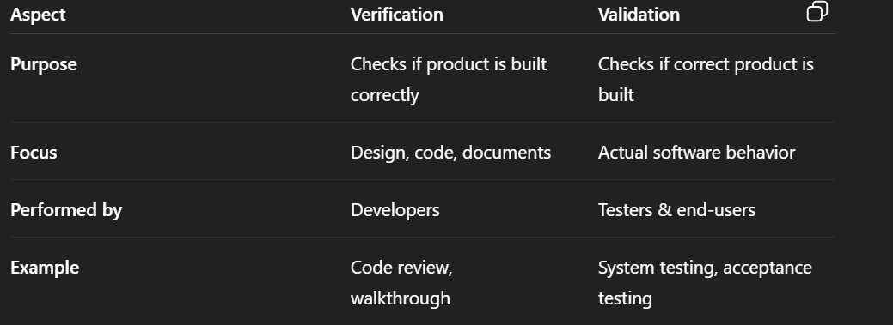
7.Distinguish between Alpha and Beta Testing.
ANS:- 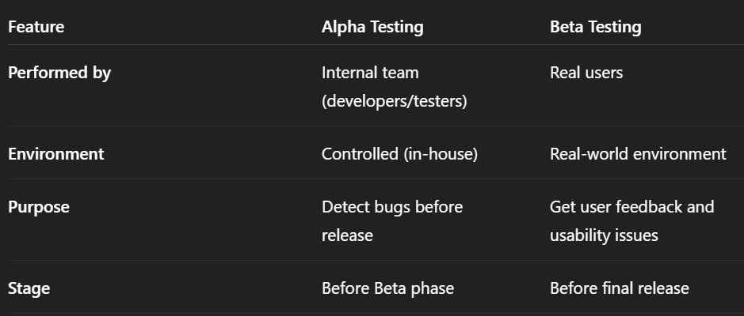
8.Examine how quality standard effect Testing?
ANS:- Examine how quality standards affect testing
- Define Testing Process Clearly:
Quality standards like ISO 9001, IEEE 829, and CMMI give clear guidelines on how testing should be planned, performed, and documented.
- Ensure Consistency and Accuracy:
Following standards helps maintain a consistent testing approach, reducing errors and confusion between team members.
- Improve Documentation and Traceability:
Standards require proper test plans, test cases, and reports — making it easier to trace bugs and verify requirements.
- Enhance Software Quality and Reliability:
With standard-based testing, defects are detected early, improving software performance, reliability, and user satisfaction.
M-5(3-Marks)
- Analyze the relationship between cohesion and coupling.
ANS:- Analyze the Relationship between Cohesion and Coupling
- Cohesion refers to how closely the elements within a module work together — higher cohesion means the module focuses on a single task.
- Coupling refers to the level of dependency between modules — lower coupling means modules are more independent.
- Relationship:
  - High cohesion usually leads to low coupling, resulting in better modularity, easy maintenance, and improved software quality.
- Compare abstraction and information hiding as complexity reduction technique.
ANS:- 1.Abstraction:
- Focuses on showing only essential features and hiding unnecessary details.
- Helps users understand the system at a higher level (e.g., using functions or classes).
2. Information Hiding:
- Focuses on protecting internal details of a module from other modules.
- Prevents direct access to data using private variables or encapsulation.

- Diff between Architectural patterns and Design patterns based on their scope.
ANS:- 1. Architectural Patterns:
- Define the overall structure and organization of the entire software system.
- Example: MVC (Model–View–Controller), Layered Architecture.
- Scope: Broad — applies to the whole system architecture.
2.Design Patterns:
- Provide solutions to common problems in specific parts or modules of software.
- Example: Singleton, Observer, Factory Method.
- Scope: Narrow — applies to individual components or classes.
- Examine how modularity contributes to achieve in functional dependencies in software system.
ANS:- Definition of Modularity:
- Modularity means dividing a software system into independent modules, each performing a specific function.
Contribution to Functional Dependency:
- Each module handles a distinct function, reducing unnecessary dependency between modules.
- Changes in one module have minimal impact on others.
Benefit:
- Improves clarity, reusability, and maintainability of the system.
- Ensures that functional dependencies are well-organized and controlled.

- Classify seven types of cohesion based on their strength.
ANS:- From weakest to strongest cohesion:
- Coincidental Cohesion – Parts are grouped randomly with no meaningful relationship.
- Logical Cohesion – Elements perform similar types of activities (e.g., all input functions).
- Temporal Cohesion – Elements executed at the same time (e.g., initialization).
- Procedural Cohesion – Elements grouped to follow a specific sequence of actions.
- Communicational Cohesion – Elements operate on the same data or input.
- Sequential Cohesion – Output of one part becomes input for another.
- Functional Cohesion – All elements work together to achieve a single, well-defined purpose.
6. Analyze the impact of type coupling on software maintainability.
ANS:- Definition:
- Coupling refers to the degree of interdependence between software modules.
- Types include data, control, stamp, and common coupling.
Impact on Maintainability:
- High coupling increases dependency — changes in one module affect others, making maintenance difficult and error-prone.
- Low coupling means modules are independent — changes can be made easily without affecting the whole system.

7.Investigate the role of refinement in top-down design methodologies.
ANS:- Investigate the Role of Refinement in Top-Down Design Methodologies
- Definition:
  - Refinement means breaking a complex problem into smaller, more detailed subproblems step by step.
- Role in Top-Down Design:
  - In top-down design, refinement helps move from a high-level concept to detailed module design.
  - Each level of refinement adds more clarity to functions and logic.
- Benefit:
  - Makes system design easier to understand, implement, and maintain, ensuring clear structure and flow.

8.Compare Command-line Interfaces with Graphical User Interfaces in terms of usability.
ANS:- 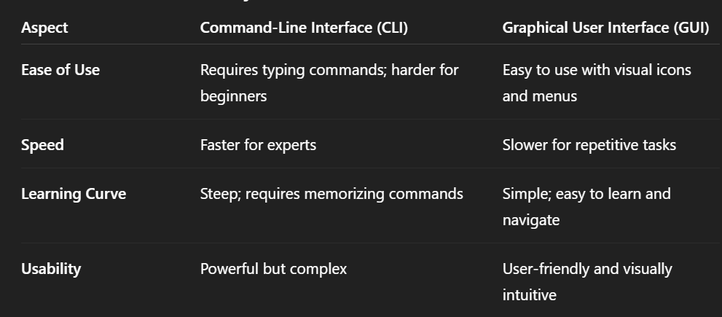
9.Categorize modern GUI elements based on their primary interaction function.
ANS:- Categorize Modern GUI Elements Based on Their Primary Interaction Function
- Input Controls:
  - Used to enter or select data — e.g., text boxes, radio buttons, checkboxes, dropdown lists.
- Navigation Components:
  - Help users move through the interface — e.g., menus, tabs, sliders, breadcrumbs.
- Information Displays:
  - Show system feedback or information — e.g., tooltips, progress bars, status messages.
10.Examine the design considerations for effective error message implementation.
ANS:- Examine the Design Considerations for Effective Error Message Implementation
- Clarity:
  - Error messages should be clear, concise, and specific about what went wrong.
- Helpfulness:
  - Provide guidance or corrective actions to fix the problem.
- User-Friendly Language:
  - Avoid technical jargon; use simple and polite language suitable for users.
11. Distinguish between procedural and object-oriented programming paradigms.
ANS:- 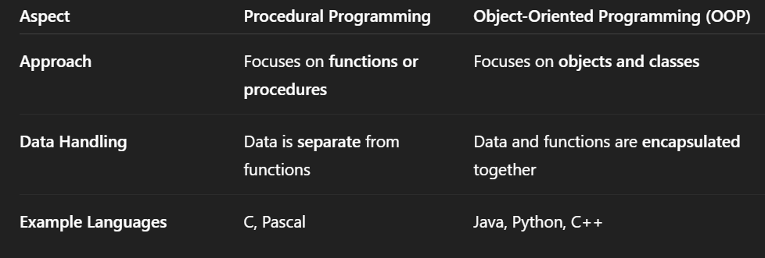
12. Analyze the criteria for selecting appropriate programming languages for specific projects.
ANS:- Project Requirements:
- Choose based on application type, e.g., web, mobile, AI, or system software.
Performance and Platform:
- Consider speed, memory efficiency, and platform compatibility.
Developer Skill and Support:
- Select a language that the team is skilled in and has strong community/library support.

13. Brief breakdown the key component that constitutes good programming practices.
ANS:- Code Readability:
- Use clear naming, proper indentation, and comments for easy understanding.
Modularity:
- Divide code into small, reusable functions or modules for better maintenance.
Error Handling & Testing:
- Include proper error handling and regular testing to ensure reliability.
14. Compare different coding standards in terms of their benefits for team development.
ANS:- 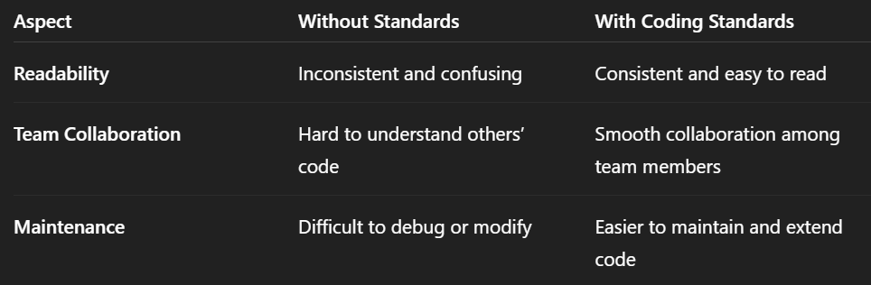
15. Investigate the relationship between user interface design principles and GUI control selection.
ANS:- i. Consistency:
- Design principles guide using familiar controls (e.g., standard buttons, menus) for uniformity.
ii. Usability:
- Appropriate GUI controls improve ease of use and reduce user errors.
iii. Feedback & Accessibility:
- Proper controls (like tooltips or alerts) ensure clear feedback and accessible interaction for all users.

M-5(3 Marks)
  - Explain how ISO 9000 standards contributes to software quality improvements.
ANS:- ISO 9000 is a set of international standards for quality management systems that ensures organizations follow consistent and effective processes.
Contribution to software quality improvements:
- It establishes standardized procedures for software development and documentation.
- Ensures continuous improvement through regular audits and feedback.
- Promotes customer satisfaction by meeting defined quality requirements.
- Reduces defects and rework by enforcing process discipline and quality assurance.

- Describe the level of the Capability Maturity Model and their importance in Software process improvement.
ANS:- The Capability Maturity Model (CMM) defines five maturity levels that measure the effectiveness of an organization’s software process:
- Level 1 – Initial: Processes are unpredictable and ad hoc. Success depends on individual effort.
- Level 2 – Repeatable: Basic project management processes are established to track cost, schedule, and quality.
- Level 3 – Defined: Processes are documented, standardized, and integrated into the organization.
- Level 4 – Managed: Processes are measured and controlled using quantitative techniques.
- Level 5 – Optimizing: Continuous process improvement is emphasized through innovation and feedback.
Importance:
CMM helps organizations improve software quality, predictability, and efficiency by moving from chaotic to well-defined and continuously improving processes.
- Explain the need for proper software project management to avoid project failure.
ANS:- Proper software project management is essential to ensure that software is delivered on time, within budget, and meets requirements.
Reasons/Needs:
- Helps in planning and scheduling tasks efficiently.
- Ensures proper resource allocation (manpower, time, and cost).
- Reduces risks and uncertainties through monitoring and control.
- Improves communication and coordination among team members and stakeholders.
- Explain how the size of software is estimated or calculated during project planning.
ANS:- Software size estimation helps in predicting effort, cost, and schedule of a project.
Common methods used are:
- Lines of Code (LOC):
  - Measures total number of source code lines.
  - Simple but language-dependent.
- Function Point (FP) Analysis:
  - Based on number of inputs, outputs, files, and user interactions.
  - Independent of programming language.
- Use Case Points (UCP):
  - Estimates size based on number and complexity of use cases.
- Expert Judgment / Delphi Method:
  - Based on experience and past project comparisons.
- Summarize the steps involved in risk mitigation, monitoring, and management plan.
ANS:- Risk Identification:
- Recognize potential risks that could affect project success (e.g., cost, schedule, technical risks).
Risk Analysis and Prioritization:
- Assess probability and impact of each risk.
- Rank risks based on severity.
Risk Mitigation Planning:
- Develop strategies to reduce or avoid high-priority risks.
- Example: Backup plans, training, additional testing.
Risk Monitoring and Control:
- Continuously track identified risks.
- Identify new risks and take corrective actions.
Risk Communication:
- Keep all stakeholders informed about risk status and actions taken.

- Explain how earned value analysis (EVA) helps track the progress and performance of a software project.
ANS:- 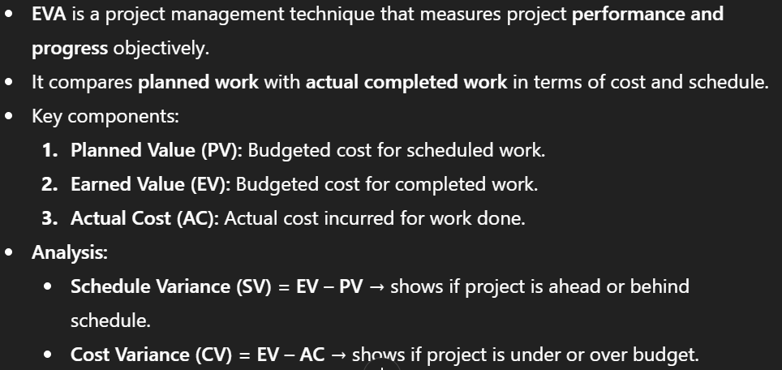
- Describe the components of network scheduling diagram and its role in project planning.
ANS:- Components:
- Activities/Tasks:
  - Represented by arrows or boxes; indicate specific project tasks.
- Events/Milestones:
  - Represent the start or completion of one or more activities.
- Dependencies:
  - Show the logical relationship or sequence between tasks (e.g., Task B depends on Task A).
- Critical Path:
  - The longest path through the network that determines the project duration.
- Slack (Float) Time:
  - The amount of time an activity can be delayed without affecting project completion.
Role in Project Planning:
- Helps visualize task sequence and dependencies.
- Identifies critical activities that need close monitoring.
- Aids in time estimation and resource allocation.
- Supports progress tracking and schedule control.
- Difference between function point analysis and lines of code (LOC). Best estimation method.
ANS:- 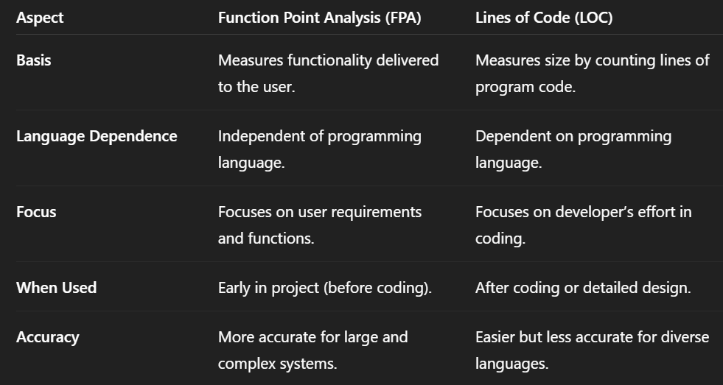
- Explain the difference between verification and validation in software testing with a suitable example.
ANS:- 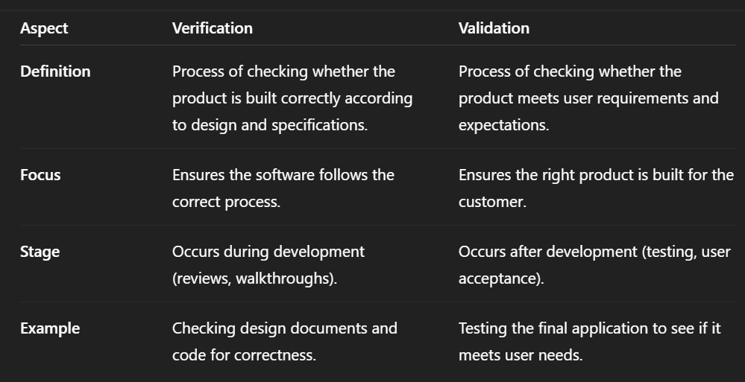
- Describe significance of Quality assurance in the software development life cycle.
ANS:- Ensures Process Quality:
QA focuses on improving and standardizing the software development process to prevent defects.
Early Defect Detection:
Identifies problems early in the SDLC, reducing rework and cost.
Improves Product Reliability:
Ensures the final product meets performance, usability, and security standards.
Customer Satisfaction:
Guarantees that the software meets user expectations and requirements.
- Design a Gantt chart for a software project security. (The last word seems to be 'security' or 'study').
ANS:-
Task | Duration (Weeks) | Week 1 | Week 2 | Week 3 | Week 4 | Week 5
Requirement Analysis | 1 | ███
System Design | 1 |  | ███
Development | 2 |  | ███ | ███
Testing & Security Audit | 1 |  |  |  | ███
Deployment & Maintenance | 1 |  |  |  |  | ███

- Formulate a risk management plan for an e-learning platform.
ANS:- 1. Risk Identification:
- Server failure or downtime.
- Data breaches or unauthorized access.
2. Risk Analysis:
- Assess probability and impact of each risk (High/Medium/Low).
3. Risk Mitigation Strategies:
- Use secure servers and regular backups.
- Regular testing and content verification.
4. Risk Monitoring:
- Continuous tracking and reporting of risk status.
- Update the plan as new risks emerge.
- Describe the purpose of regression testing when it is applied in a project.
ANS:-Purpose:
Regression testing ensures that new changes, bug fixes, or updates do not negatively affect the existing functionalities of the software.
When Applied:
- After code modifications or new feature additions.
- After bug fixing or performance enhancements.
- During integration or system testing stages.
Process:
- Re-run previously executed test cases to verify that old functions still work correctly.
Benefits:
- Detects unintended side effects of code changes.
- Maintains software stability and reliability after updates.

